Title via the sentence case capitalisation:
Sub-title via the sentence case capitalisation
Author 1¹, Author 2² and Author 3¹ // Please write full names. LUMAT uses single blind review system (Anonymous Reviewer/Disclosed Author).
¹ Institution name, country
² Institution name, country
Abstract: A single paragraph maximum of 250 words. The abstract is also metadata and therefore, the most read part of the article. It should give a comprehensive overview of the work. Please follow the standard abstract structure if possible. Start by describing the background and highlight the purpose of the study. Then describe methods and continue to the main results. Last phase is to summarise the main conclusions.
Keywords: keyword 1, keyword 2, keyword 3, keyword 4, keyword 5
Correspondence: email

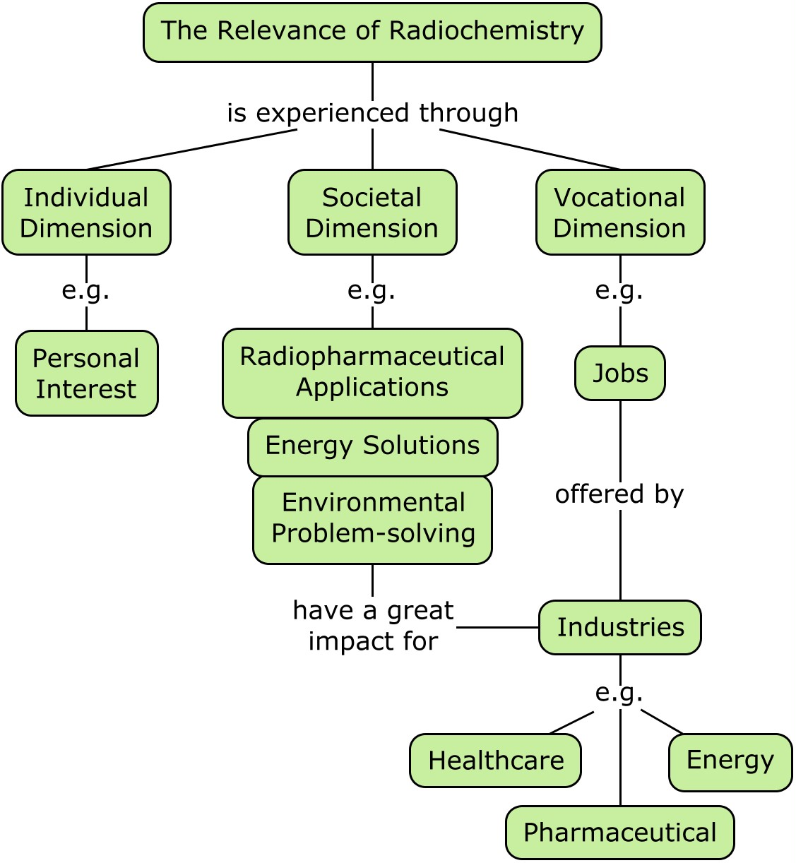
The graphical abstract provides a “quick visual representation” of the results or some other specific focus of the work. The graphical abstract differentiates from other figures included in the manuscript. Above you see an example of a graphical abstract, but it doesn’t have to be a concept map.

Please note that all metadata must fit on the first page.

1 Write headings via the sentence case capitalisation
Paragraph - first: use this for the first paragraph in a section, or to continue after an extract. Paragraph - first: use this for the first paragraph in a section, or to continue after an extract. Paragraph - first: use this for the first paragraph in a section, or to continue after an extract.

1.1 Heading 2
Paragraph - first: use this for the first paragraph in a section, or to continue after an extract. Paragraph - first: use this for the first paragraph in a section, or to continue after an extract. Paragraph - first: use this for the first paragraph in a section, or to continue after an extract (Justi & Gilbert, 2003).
Paragraph: use this style when you need to begin a new paragraph. New paragraph: use this style when you need to begin a new paragraph. New paragraph: use this style when you need to begin a new paragraph. New paragraph: use this style when you need to begin a new paragraph. Paragraph: use this style when you need to begin a new paragraph. New paragraph: use this style when you need to begin a new paragraph. New paragraph: use this style when you need to begin a new paragraph. New paragraph: use this style when you need to begin a new paragraph (Aksela, 2019).
Paragraph: use this style when you need to begin a new paragraph. New paragraph: use this style when you need to begin a new paragraph. New paragraph: use this style when you need to begin a new paragraph. New paragraph: use this style when you need to begin a new paragraph.
Quotations Lorem Ipsum Lorem Ipsum Lorem Ipsum Lorem Ipsum Lorem Ipsum Lorem Ipsum Lorem Ipsum Lorem Ipsum Lorem Ipsum Lorem Ipsum Lorem Ipsum Lorem Ipsum Lorem Ipsum Lorem Ipsum Lorem Ipsum Lorem Ipsum (Respondent 15)
Paragraph: use this style when you need to begin a new paragraph. New paragraph: use this style when you need to begin a new paragraph. New paragraph: use this style when you need to begin a new paragraph. New paragraph: use this style when you need to begin a new paragraph (Pernaa et al., 2023).
- Style for numbered lists is L_List – numbered.
Paragraph: use this style when you need to begin a new paragraph. New paragraph: use this style when you need to begin a new paragraph. New paragraph: use this style when you need to begin a new paragraph. New paragraph: use this style when you need to begin a new paragraph (Aksela, 2010).
- Style for bulleted lists is L_List – bulleted.

Paragraph - first: use this for the first paragraph in a section, or to continue after an extract. Paragraph - first: use this for the first paragraph in a section, or to continue after an extract. Paragraph - first: use this for the first paragraph in a section, or to continue after an extract.
Paragraph: use this style when you need to begin a new paragraph. New paragraph: use this style when you need to begin a new paragraph. New paragraph: use this style when you need to begin a new paragraph. New paragraph: use this style when you need to begin a new paragraph.
Displayed equation ( )
Paragraph: use this style when you need to begin a new paragraph. New paragraph: use this style when you need to begin a new paragraph. New paragraph: use this style when you need to begin a new paragraph. New paragraph: use this style when you need to begin a new paragraph. New paragraph: use this style when you need to begin a new paragraph. New paragraph: use this style when you need to begin a new paragraph. New paragraph: use this style when you need to begin a new paragraph.
- Table caption
Header cell |  | Header cell |  | Header cell
Header cell | Header cell | Header cell | Header cell | Header cell | Header cell
Lorem | 26 | Lorem | 20 | Lorem | 13
Ipsum | 9 | Ipsum | 20 | Ipsum | 13
 |  | Lorem | 11 | Lorem | 4
 |  | Ipsum | 11 | Ipsum | 24
 |  |  |  | Lorem | 7
Note. Every table will need a note that will be included also as the alternative text. Right click on the table. Select Table Properties. And title and alternative description to Alt Text.
Paragraph: use this style when you need to begin a new paragraph. New paragraph: use this style when you need to begin a new paragraph. New paragraph: use this style when you need to begin a new paragraph. New paragraph: use this style when you need to begin a new paragraph. New paragraph: use this style when you need to begin a new paragraph. New paragraph: use this style when you need to begin a new paragraph. New paragraph: use this style when you need to begin a new paragraph. New paragraph: use this style when you need to begin a new paragraph. New paragraph: use this style when you need to begin a new paragraph. New paragraph: use this style when you need to begin a new paragraph.
- Type your figure title here
Note. Every image will need a note that will be included also as the alternative text. Obtain permission and include the acknowledgement required by the copyright holder if a table is being reproduced from another source.
Paragraph: use this style when you need to begin a new paragraph. New paragraph: use this style when you need to begin a new paragraph. New paragraph: use this style when you need to begin a new paragraph. New paragraph: use this style when you need to begin a new paragraph.

1.1.1 Heading 3
Lorem ipsum Lorem Ipsum Lorem ipsum Lorem Ipsum Lorem ipsum Lorem Ipsum Lorem ipsum Lorem Ipsum. (Bienfait & Ertl, 2013)
Paragraph: use this style when you need to begin a new paragraph. New paragraph: use this style when you need to begin a new paragraph. New paragraph: use this style when you need to begin a new paragraph. New paragraph: use this style when you need to begin a new paragraph.
Paragraph: use this style when you need to begin a new paragraph. New paragraph: use this style when you need to begin a new paragraph. New paragraph: use this style when you need to begin a new paragraph. New paragraph: use this style when you need to begin a new paragraph.

Conclusions
Lorem ipsum Lorem Ipsum Lorem ipsum Lorem Ipsum Lorem ipsum Lorem Ipsum Lorem ipsum Lorem Ipsum. (Bienfait & Ertl, 2013)
Paragraph: use this style when you need to begin a new paragraph. New paragraph: use this style when you need to begin a new paragraph. New paragraph: use this style when you need to begin a new paragraph. New paragraph: use this style when you need to begin a new paragraph.

Research ethics

Author contributions
For research articles with several authors, a short paragraph specifying their individual contributions must be provided. The following statements following the CrediT taxonomy must be used. For example:
“A.A.: conceptualization, investigation, methodology, project administration, validation, visualization, writing—original draft preparation, writing—review and editing
B.B.: formal analysis, writing—review and editing
C.C.: data curation, funding acquisition, supervision, writing—review and editing.
All authors have read and agreed to the published version of the manuscript.”

Artificial intelligence
Describe if artificial intelligence has been used in the research or writing the article. Also, specify which software was used.

Funding
Specify possible funding details.

Institutional review board statement
LUMAT journals follow research ethical guidelines recommended by The Finnish National Board on Research Integrity TENK: https://tenk.fi/en. According to it, all research settings including humans do not need to be reviewed by the institutional research ethics boards. For example, if the study focuses on 15-year-old pupils or older, their own consent is sufficient for participation in the research. Read more about the ethical review guidelines applied in Finland.

Informed consent statement
Research that includes humans must contain this statement. Please add “Informed consent was obtained from all research participants.” OR “The informed consent was waived due to REASON (please provide a detailed justification).” OR “Not applicable.” for studies not including human participants.

Data availability statement
LUMAT encourages scholars to share their research data. Please provide details regarding where data supporting reported results can be found, including links to publicly archived datasets. A data availability statement is required even if no new data were gathered, or data is unavailable due to privacy or ethical restrictions.

Acknowledgements
This is the section to thank all collaborators, donators etc.

Conflicts of Interest
Declare conflicts of interest or state “The authors declare no conflicts of interest.” In this section authors should describe if funders had any role in designing the research setting, analysis procedures or interpretation of the results.

Appendix A
Include survey instruments and interview schemas as appendices to the manuscript.

References
Aksela, M. (2010). Evidence-based teacher education: Becoming a lifelong research-oriented chemistry teacher? Chemistry Education Research and Practice, 11(2), 84–91. https://doi.org/10.1039/C005350N
Aksela, M. (2019). Towards student-centred solutions and pedagogical innovations in science education through co-design approach within design-based research. LUMAT: International Journal of Math, Science and Technology Education, 7(3). https://doi.org/10.31129/LUMAT.7.3.421
Bienfait, B., & Ertl, P. (2013). JSME: A free molecule editor in JavaScript. Journal of Cheminformatics, 5(1), 24. https://doi.org/10.1186/1758-2946-5-24
Justi, R., & Gilbert, J. (2003). Models and modelling in chemical education. In J. Gilbert, O. de Jong, R. Justi, D. F. Treagust, & J. H. Driel (Eds.), Chemical Education: Towards Research-based Practice (pp. 47–68). Springer Netherlands.
Pernaa, J., Takala, A., Ciftci, V., Hernández-Ramos, J., Cáceres-Jensen, L., & Rodríguez-Becerra, J. (2023). Open-Source Software Development in Cheminformatics: A Qualitative Analysis of Rationales. Applied Sciences, 13(17), Article 17. https://doi.org/10.3390/app13179516

This is a footnote.

